**Called to follow**

**Reading: Luke 5:27-32**

Jesus went out and saw a tax collector sitting at his place for collecting taxes. His name was Levi. Jesus said to him, “Follow me!”. Levi got up, left everything and followed Jesus.

Then Levi gave a big dinner at his house for Jesus. At the table were many tax collectors and some other people too. But the Pharisees and those who taught the law began to complain to the followers of Jesus, “Why do you eat with tax collectors and other sinners?”

Jesus answered them, “It is the sick people who need a doctor, not those who are healthy. I have not come to ask good people to change. I have come to ask sinners to change the way they live.”

**Thought about the reading**

Jesus calls surprising people to follow him – people that others might think were no good. Levi was someone like that.

People did not like Levi. He collected money for the Roman rulers. He took a bit extra for himself as well. He was not the sort of person you would want to be friends with.

Jesus was not worried that Levi was not a good man. He called him because he knew that he could help Levi to change. Levi heard Jesus calling him to follow and he left his old life to start a new one as one of Jesus’ special friends.

Jesus also calls us to follow him. We don’t have to be good, or clever or rich. All we have to do is say, ‘Yes, I want to follow Jesus.’ He will help us to follow him.

**Prayer**

Lord Jesus, thank you that you call surprising people to follow you. You don’t call people because they are clever or good – you call people who want to change.

Thank you that you have called me. I want to follow you. Please help me to change so that I can follow you like Levi did.

Amen

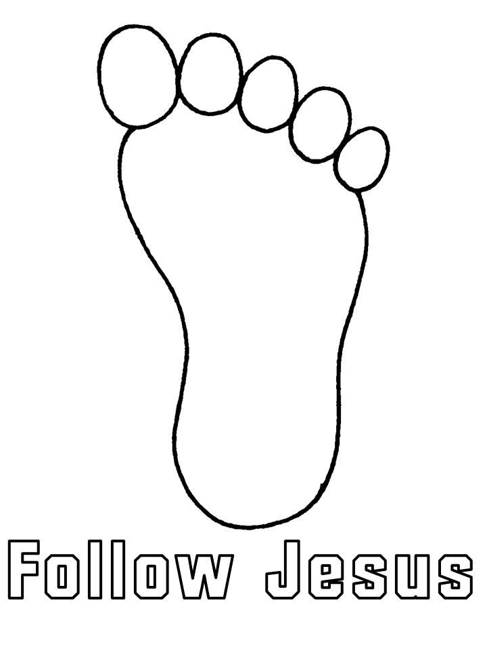

Decorate the footprint and then write your name on it to show that you want to follow Jesus.

**Cambridge Causeway**

Summer 2022

Bible Study notes

**Following Jesus**

1. Called to follow

By Chrissy Cole